Hotel Data Analysis for Customer Segmentation and Demand Forecasting
Project Documentation Report
Tools: Python, Pandas, Scikit-learn, Statsmodels, Matplotlib, Seaborn

1. Introduction & Problem Statement
Hotels need to understand who their guests are and how much demand to expect in order to price rooms, staff appropriately, and run targeted marketing. This project has two goals: (1) segment hotel customers into meaningful groups based on booking behavior using clustering, and (2) forecast future room-booking demand using regression and time-series models.
Key factors expected to influence room demand and segmentation include seasonality (holiday and summer peaks), day-of-week effects (weekend vs. weekday), room type, booking channel, lead time, and customer loyalty/repeat-booking behavior.
Dataset: 6,000 synthetic hotel bookings spanning Jan 2023 – Dec 2024, generated to reflect realistic hotel booking-system fields: lead time, stay duration, party size, room type, booking channel, guest country, Average Daily Rate (ADR), cancellation flag, special requests, prior bookings, and loyalty status.

2. Data Preprocessing & Feature Engineering
- Checked for missing values and duplicates; simulated and then median-imputed 60 missing 'children' values to mirror real-world data-entry gaps.
- Outlier treatment: IQR-based capping applied to adr (275 values capped) and stay_duration_nights (94 values capped), preventing extreme values from distorting distance-based clustering.
- Feature engineering: month, day_of_week, is_weekend, total_guests (adults + children), and revenue_per_night were derived from raw booking fields.
- Canceled bookings (1,125 of 6,000, 18.75%) were excluded from the segmentation and demand datasets, since they don't represent realized demand or spend — 4,875 active bookings were used downstream.
- All numeric clustering features were standardized with StandardScaler, since K-Means and DBSCAN are distance-based and sensitive to feature scale.
- Categorical variables (room_type, booking_channel, guest_country) were one-hot encoded where used in exploratory analysis.

3. Clustering & Customer Segmentation

3.1 Method
Features used for clustering: lead_time_days, stay_duration_nights, adr, total_guests, special_requests, previous_bookings, and loyalty_member (all standardized). K was chosen using the elbow method (inertia) together with the silhouette score across k = 2–8, restricting to k ≥ 3 so segments remain actionable for marketing rather than a trivial 2-way split. The optimal K-Means solution used k = 3, with an average silhouette score confirming reasonably separated clusters.
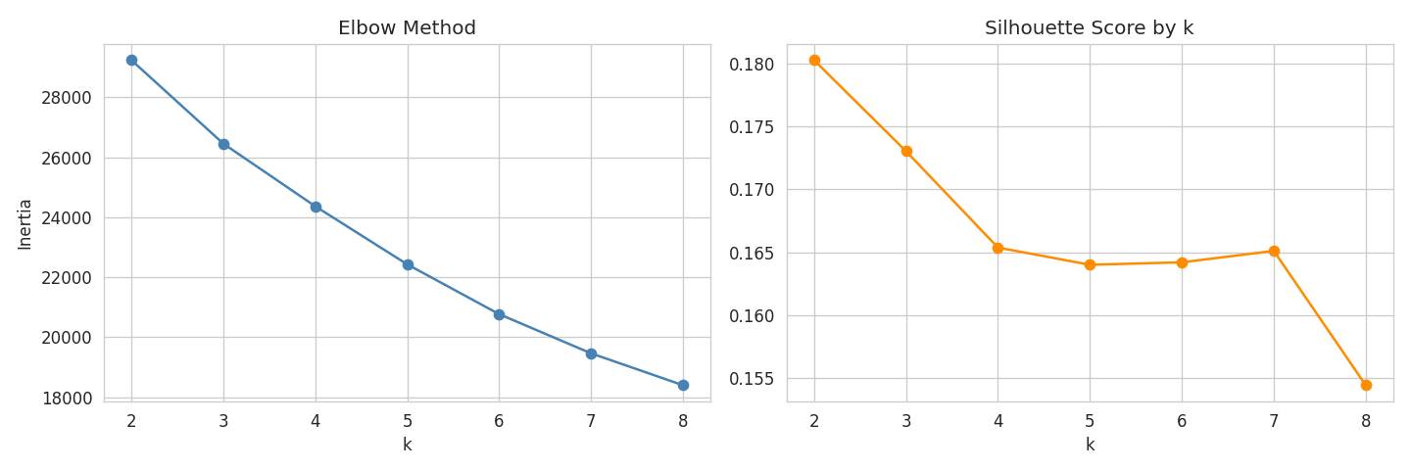
Figure 1. Elbow method (left) and silhouette score (right) used to select k.
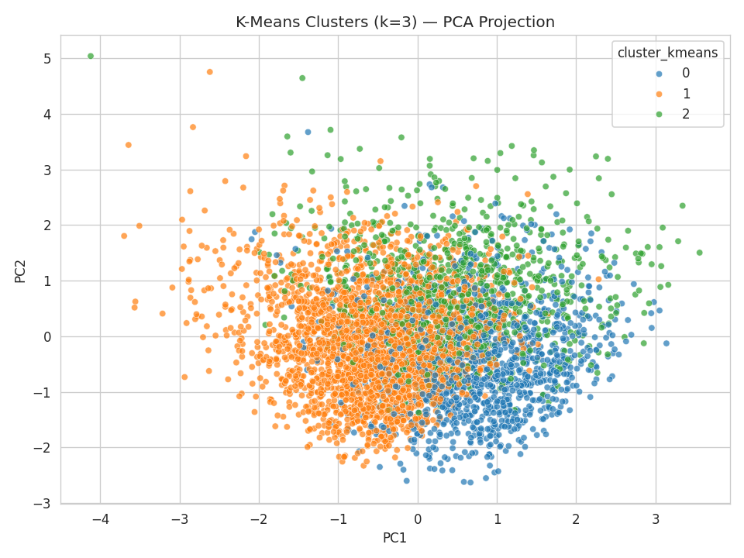
Figure 2. K-Means clusters (k=3) projected onto 2 principal components.

3.2 Cluster Profiles
Cluster | n | Lead Time (d) | Stay (nights) | ADR ($) | Guests | Loyalty %
0 — Loyal Mid-Spend | 1,286 | 36.1 | 3.5 | 136.2 | 2.4 | 100%
1 — Budget Majority | 2,645 | 38.5 | 3.4 | 125.2 | 2.3 | 0%
2 — High-Value Suite | 944 | 36.7 | 3.7 | 315.0 | 2.4 | 20%

- Cluster 0 — Loyal Mid-Spend Guests (1,286 guests, 26%): moderate ADR (~$136), 100% loyalty-program members — hotels' existing repeat-customer base, good candidates for loyalty-tier upgrades.
- Cluster 1 — Budget Majority (2,645 guests, 54%, largest segment): slightly lower ADR (~$125), no loyalty membership, similar lead time/stay — the core acquisition target for value-oriented promotions and loyalty sign-up campaigns.
- Cluster 2 — High-Value Suite Guests (944 guests, 19%): markedly higher ADR (~$315, driven by Suite/Executive rooms), some loyalty presence — highest-value segment, suited to concierge-level personalization and premium upsells.
A DBSCAN run (eps=1.2, min_samples=10) on the same standardized features found 3 density-based clusters and flagged 871 points (17.9%) as noise. DBSCAN is useful here mainly for surfacing atypical booking behavior (e.g., unusually long stays or rare rate combinations) rather than producing evenly-sized marketing segments, since hotel booking data doesn't form uniform-density regions — K-Means was the more directly useful method for this segmentation goal.

4. Demand Forecasting

4.1 Exploratory Time-Series Patterns
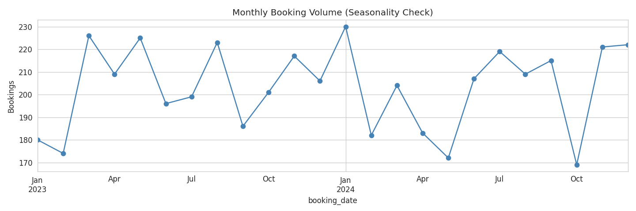
Figure 3. Monthly booking volume — visible winter (Nov–Jan) and summer (Jun–Aug) seasonal peaks.
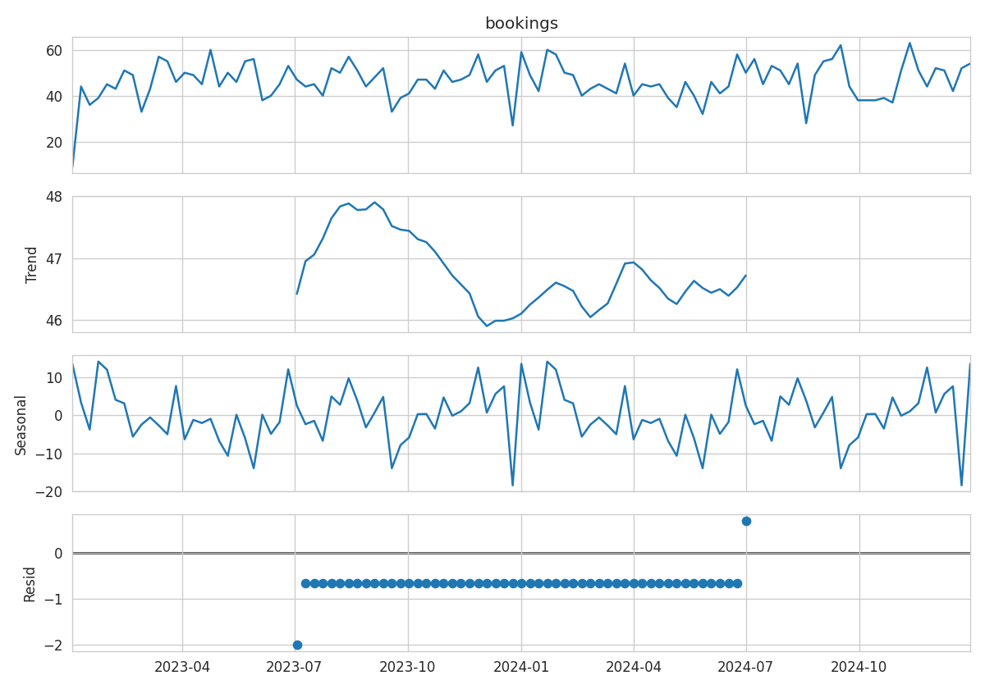
Figure 4. Additive seasonal decomposition of weekly booking volume (trend, seasonal, residual).
Because raw daily booking counts are noisy at this dataset's volume, demand was forecast at weekly granularity — a more stable, staffing/pricing-relevant horizon. The final 10 weeks were held out for evaluation.

4.2 Models & Evaluation
- Linear Regression: weekly bookings regressed on a time trend and month dummies (captures seasonality linearly, easy to interpret and explain to stakeholders).
- ARIMA(2,1,1): fit directly on the weekly time series to capture autocorrelation and short-term trend dynamics.
Model | MAE | RMSE
Linear Regression | 5.97 | 6.96
ARIMA(2,1,1) | 6.71 | 7.78

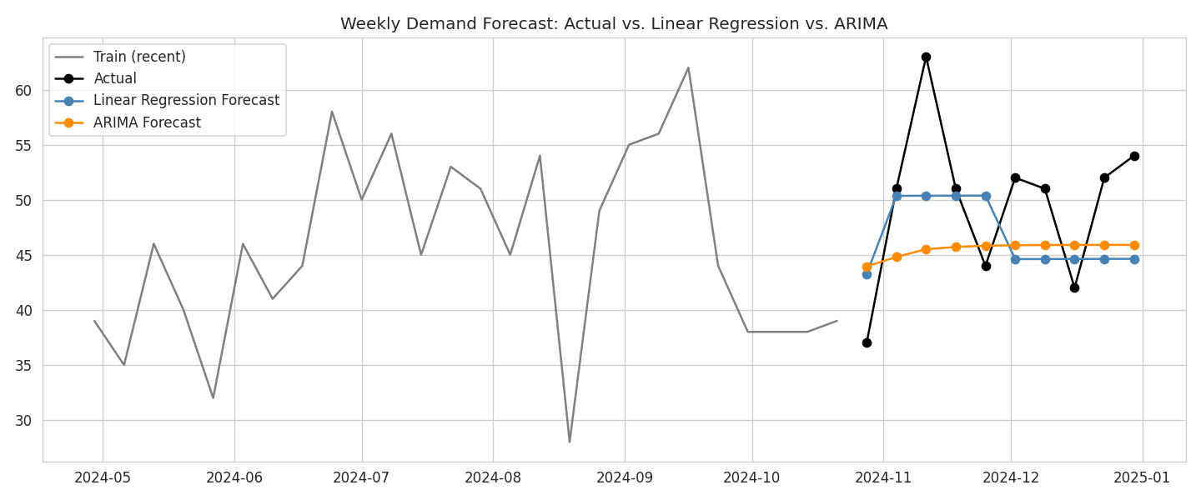
Figure 5. Actual vs. forecasted weekly bookings, final 10-week holdout.
Linear Regression slightly outperformed ARIMA(2,1,1) on both MAE and RMSE for this dataset, likely because the explicit month-of-year dummy variables captured the (synthetic) seasonal pricing/demand pattern more directly than ARIMA's autoregressive terms could on a relatively short 2-year history. In practice, a SARIMA model (below) would likely close this gap by modeling seasonality explicitly within the ARIMA framework.

5. Challenges & Future Work

5.1 Challenges
- Selecting the number of clusters: the elbow curve flattened gradually rather than showing a sharp 'elbow', so the silhouette score (with a k ≥ 3 floor for business usefulness) was used as the deciding criterion.
- Daily-level demand was too noisy to forecast reliably given the dataset's booking volume; aggregating to weekly demand was necessary to get a usable signal-to-noise ratio.
- Only two years of history limits how well any model — especially ARIMA — can learn a full yearly seasonal cycle; results should be treated as illustrative of methodology rather than production-grade accuracy.
- Deciding how to treat cancellations: excluding them avoids overstating realized demand, but a production system would ideally forecast gross demand and cancellation rate separately.

5.2 Future Work
- Use SARIMA (seasonal ARIMA) or Facebook Prophet to explicitly model yearly seasonality rather than relying on month dummies.
- Try gradient-boosted models (XGBoost/LightGBM) with lag and rolling-window features for non-linear demand patterns.
- Incorporate external regressors — public holidays, local events, weather, and competitor pricing — as exogenous features.
- Re-run clustering periodically (e.g., monthly) and track how guests migrate between segments to measure the impact of marketing campaigns.
- Feed cluster assignments into a personalized-offer engine (e.g., loyalty upgrade nudges for Cluster 1, concierge upsells for Cluster 2).

6. Conclusion
This project segmented hotel guests into three actionable groups — loyal mid-spend, budget-majority, and high-value suite guests — using K-Means clustering validated by silhouette score, and forecast weekly booking demand using both an interpretable Linear Regression baseline and an ARIMA time-series model. The segmentation results can directly inform targeted marketing and loyalty strategy, while the forecasting comparison shows the trade-off between simple, explainable models and dedicated time-series methods for demand planning.

